姓名： 报考专业： 准考证号码： | 密封线内不要写题
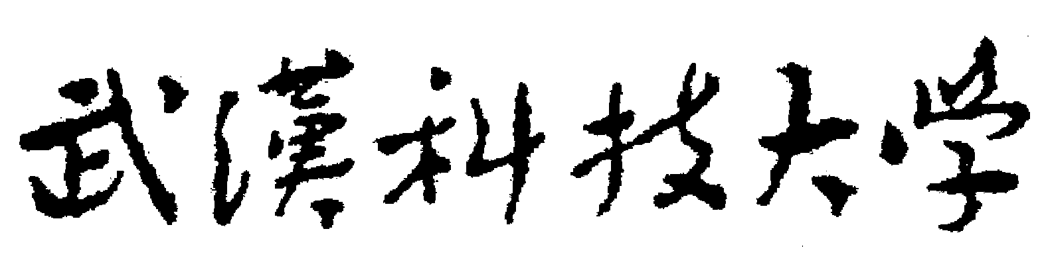2020年全国硕士研究生招生考试初试自命题试题
参考答案及评分标准
科目名称：写作与翻译（A卷□B卷）科目代码：858
考试时间：3小时 满分150 分
可使用的常用工具：无 □计算器 □直尺 □圆规（请在使用工具前打√）
Part One Translation (75 points)
I. Translate the following into Chinese. (40 points, 8 points for each item)
1. 世界上有两种人，他们的健康、财富、以及生活上的各种享受大致相同，结果， 一种人是幸福的，另一种却得不到幸福。他们对物、对人、和对事的观点不同，那些观点对于他们心灵上的影响因此也不同，苦乐的分野主要的也就在此。
2. 英国风景最大的美，据我看来，乃是一种道德的美。这种道德的美随处流露，我们看见了英国的田园风景，心里就会联想到秩序和安静的种种观念，联想到和平的深入人心的种种原则，历代相传的风俗。以及受人重视的习惯。
3. 随着家庭成员与他们稳定的社区、多年的老友和大家庭的亲属关系相分离，非正式的信息渠道被切断了， 而那种在需要时就能得到真实可靠信息的信心也丢失了。
4. 除非你有钱，否则长得俊秀也白搭。穷人应当讲求实际，不要特殊。长相好不如钱多。这些都是现代生活的至理名言，而他却从未领悟。
5. 实质上，这是一种寄生式的生活方式，采取此策略的人通过这样或那样的方式寄生于这个他们蔑视的社会，并且拒绝对这个社会承担责任。
II. Translate the following into English. (35 points, 7 points for each item)
1. With expressive, simple language, this short story is a testament to the author’s writing ability, particularly in terms of plot and conception.
2. Shall I love you to the end of time! Till mountains crumble, streams run dry, thunder rumbles in winter, snow falls in summer, and the earth mingles with the sky---not till then will I cease to love you!
3. China’s reform began in the countryside with the aim of adjusting the relationship between peasants and land. Before 1978, hundreds of millions of Chinese struggle with their daily food and clothing. Nowadays, after 40 years of reform and opening-up, more than 700 million rural poor people have been lifted out of poverty.
4. Confucian scholar Mozi promotes a concept of Da ai, a “big love” or, more appropriately, “respect for others and things”. If expressed in an altruistic way, this makes for an easy, positive unification of people, countries, man and nature.
5. We feel most comfortable with them, and naturally we are willing to get associated with people of similar family conditions in finance and status.
Translation Scoring Guidelines
7-8: EXCELLENT TRANSLATION
The translation faithfully reflects the original text with only 1 or 2 minor errors in vocabulary, syntax, punctuation or spelling. The translation is elegant (appropriate choice of words, a variety in sentence patterns).
5-6: GOOD TRANSLATION WITH FEW INACCURACIES
The translation reflects almost the original text with relatively few significant errors of vocabulary, syntax, spelling or punctuation. The translation is readable (generally clear, smooth and cohesive).
3-4: PASSABLE TRANSLATION WITH SOME INACCURACIES
The translation adequately reflects most of the original text with occasional errors of vocabulary, syntax, spelling or punctuation. The translation is, for the most part, readable.
1-2: INADEQUATE TRANSLATION WITH FREQUENT INACCURACIES
The translation only reflects a small part of the original text with frequent errors of vocabulary, syntax, spelling or punctuation. The translation is, in some parts, unreadable.
Part Two Writing (75 points)
I. Write a letter on the following topic (25 points). (Omitted)
II. Write an essay on the following topic (50 points). (Omitted)
Writing Scoring Guidelines
46-50: EFFECTIVE COMMUNICATION WITH ACCURACIES
The writing effectively addresses the writing task. It demonstrates a well developed logical organizational structure with clearly stated main ideas and sufficient supporting details. It has almost no errors of vocabulary, spelling, punctuation or syntax, and it displays an adequate ability to use the language with appropriacy.
36-45: GOOD COMMUNICATION WITH FEW INACCURACIES
The writing adequately addresses almost all of the writing task, though it deals with some parts more effectively than others. It demonstrates a generally well developed logical organizational structure with main ideas and supporting details. It has relatively few significant errors of vocabulary, spelling, punctuation or syntax, and it displays an ability to use the language with appropriacy.
26-35: PASSABLE COMMUNICATION WITH SOME INACCURACIES
The writing adequately addresses most of the writing task. On the whole, it demonstrates an adequately developed organizational structure, though there may occasionally be a lack of relevance, clarity, consistency or support. It has occasional errors of vocabulary, spelling, punctuation or syntax, which may, from time to time, obscure meaning, and for the most part it displays some ability to use the language with appropriacy.
16-25: PROBLEMATIC COMMUNICATION WITH FREQUENT INACCURACIES
The writing only addresses some of the writing task. It demonstrates an inadequate organizational structure, and there may quite often be a lack of relevance, clarity, consistency or support. It has frequent errors of vocabulary, spelling, punctuation or syntax, and it displays a limited ability to use the language with appropriacy.
0-15: ALMOST NO COMMUNICATION

